**DAILY ONLINE ACTIVITIES SUMMARY**

|  |  |  |  |  |  |  |  |  |
| --- | --- | --- | --- | --- | --- | --- | --- | --- |
| **Date:** | **10/06/2020** | | | | | **Name:** | **AKASH S** | |
| **Sem & Sec** | **4TH&A** | | | | | **USN:** | **4AL18CS004** | |
| **Online Test Summary** | | | | | | | | |
| **Subject** | | **OBJECT ORIENTED CONCEPTS** | | | | | | |
| **Max. Marks** | | **30** | | **Score** | | | **16** | |
| **Certification Course Summary** | | | | | | | | |
| **Course** |  | | | | | | | |
| **Certificate Provider** | | | **GREAT LEARNING** | | **Duration** | | | **3.5 HOURS** |
| **Coding Challenges** | | | | | | | | |
| **Problem Statement 1: Write a C Program to print the sum of boundary elements of a matrix**  **Problem Statement 2:**  **Java Program to find the longest repeating sequence in a string**  **Problem Statement 3:Write a java program to count all the triplets such that sum of two elements equals the third element.** | | | | | | | | |
| **Status: executed** | | | | | | | | |
| **Uploaded the report in Github** | | | | | **YES** | | | |
| **If yes Repository name** | | | | | <https://github.com/akashacharya786/lockdown-c-coding>  **https://github.com/akashacharya786/lockdown-java-coding** | | | |
| **Uploaded the report in slack** | | | | | **YES** | | | |

Online Test Summary: OOC online test was scheduled from 9:15AM to9:45 am. The portion for the IA was module 3 and 4. The question were MCQ type There were 15 question each question carries 2 mark respectively duration is 30 minutes .The score I received was 16/30.

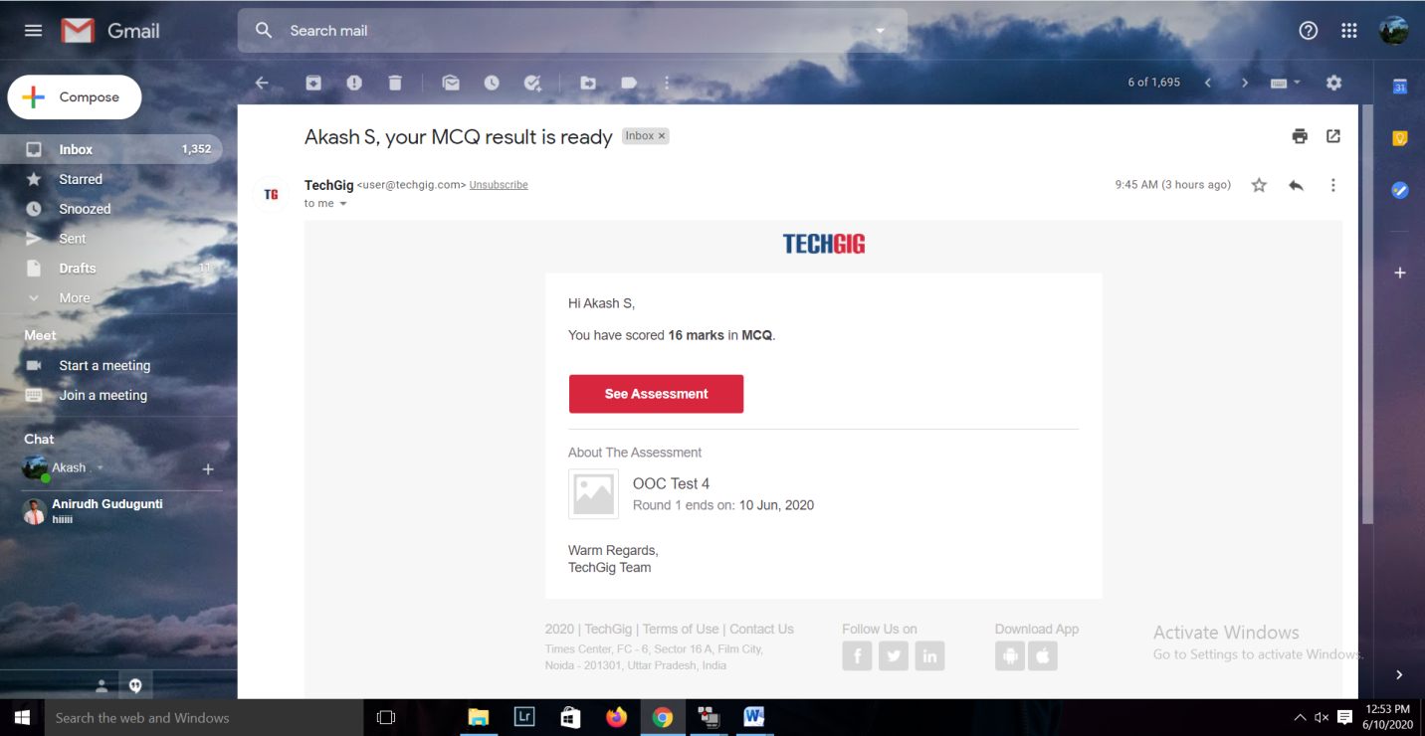

**Online Certification course:**

Today I have started a new course

Name of the course : Front end Development-HTML

Duration: 3.5 hours

Certificate provider: great learning

Snap shot:



In this video today I learnt about introduction to front end, creating a HTML file, Tags.

Online Coding summary:

**1.   Write a C Program to print the sum of boundary elements of a matrix**

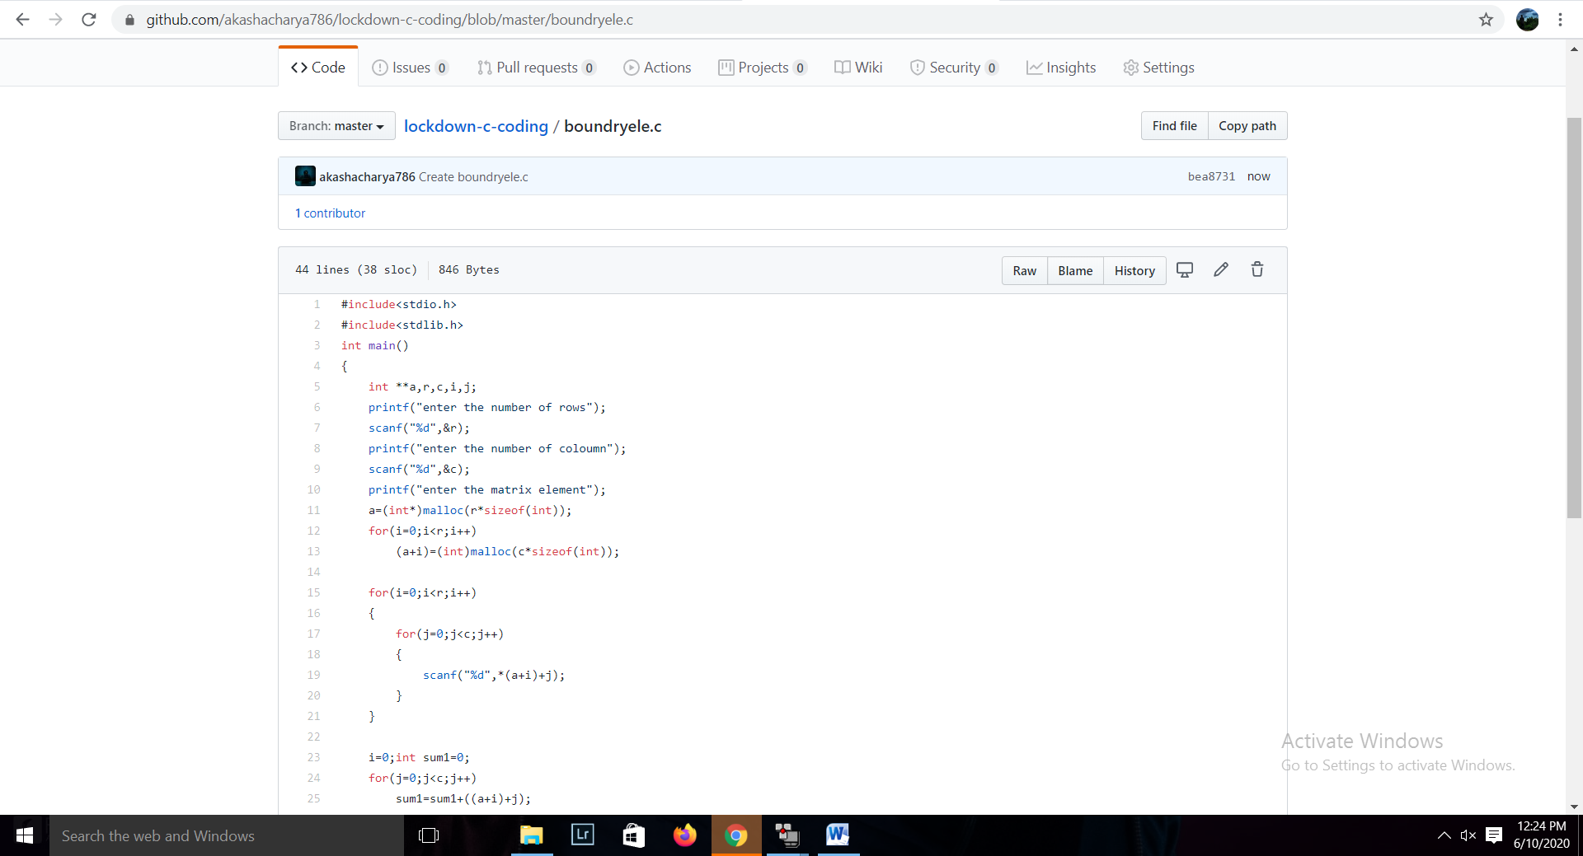

**2. Java Program to find the longest repeating sequence in a string**

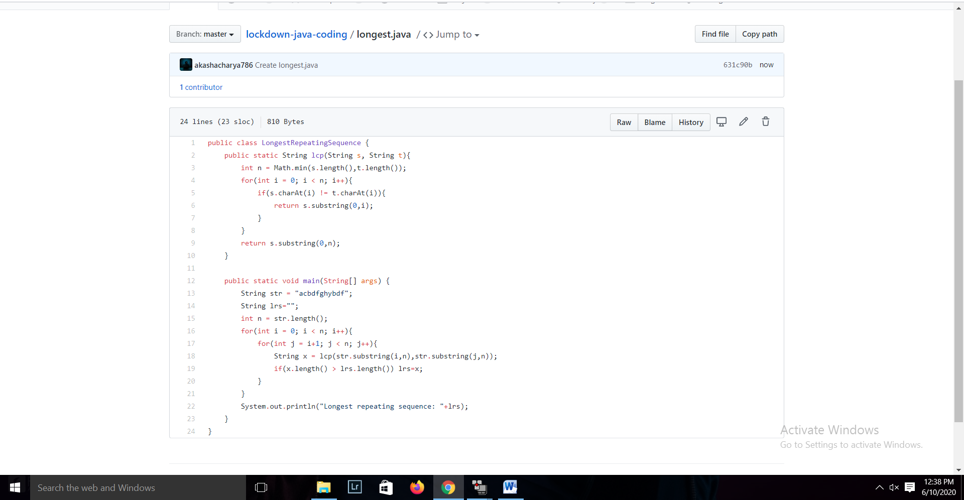

**3.Write a java program to count all the triplets such that sum of two elements equals the third element.**

